Significant donations from businesses like yours help us to continue to impact the lives of Muslim women across Scotland and boosts our organisations sustainability. We are keen to work with a number of corporate sponsors to manage their gifts of £5,000 and over. Amina MWRC’s work falls under the following UN sustainable development goals:

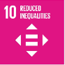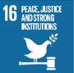

- What we offer our partners
- Tailored proposals
- A dedicated sponsorship manager
- Invitations to exclusive events
- Recognition on our website, promotional materials and end of year reports

If you are interested in exploring a corporate sponsorship or philanthropic relationship with Amina, please contact Sarah on 0141 212 8420 or email sarah@mwrc.org.uk

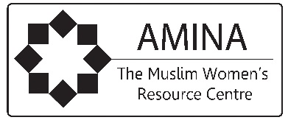

Scottish Charity No: SC027690
Registered in Scotland No: SC43291

